EXPERIMENT 7: - Create a simple cloud software application for Students Attendance System using any Cloud Service Provider to demonstrate SaaS include the necessary fields such as name of the students, course, present, Absent, course attendance, OD request, grade, attendance percentage, etc.

Step 1: - Go to ZOHO.com

Step 2: - Create and account and log into the account

Step 3: - Create an application

Step 4: - Create login form

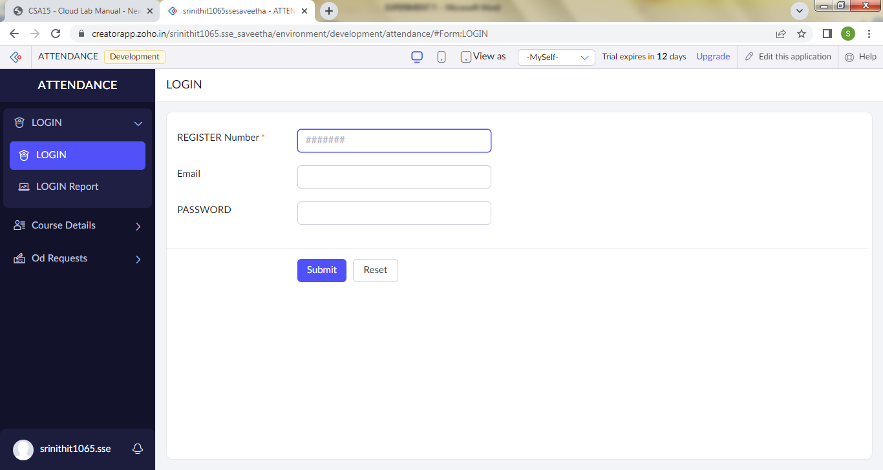

Step 5: - Create a form for course details

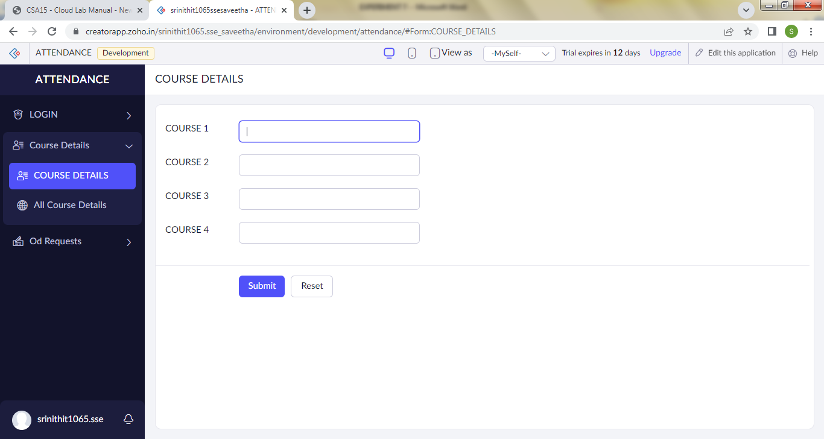

Step 6: - Create a form for OD request

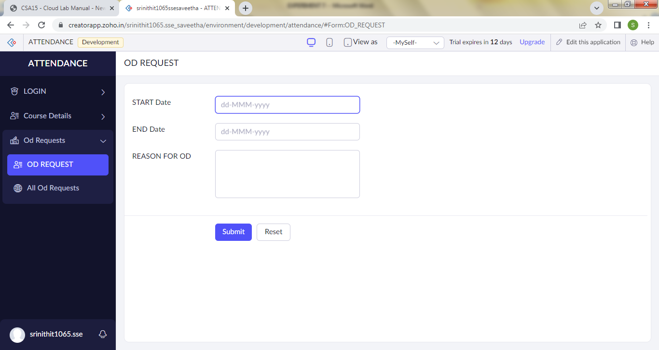

Step 7: - Create a form for results

Step 8: - Click on the Access development live to view the output

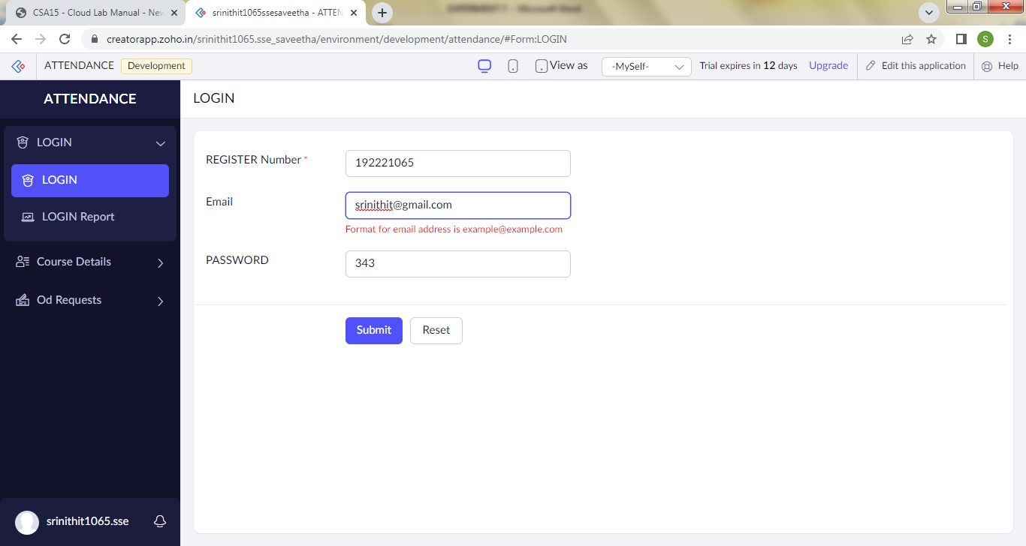

Step 9: - Click on the report to see the saved data’s

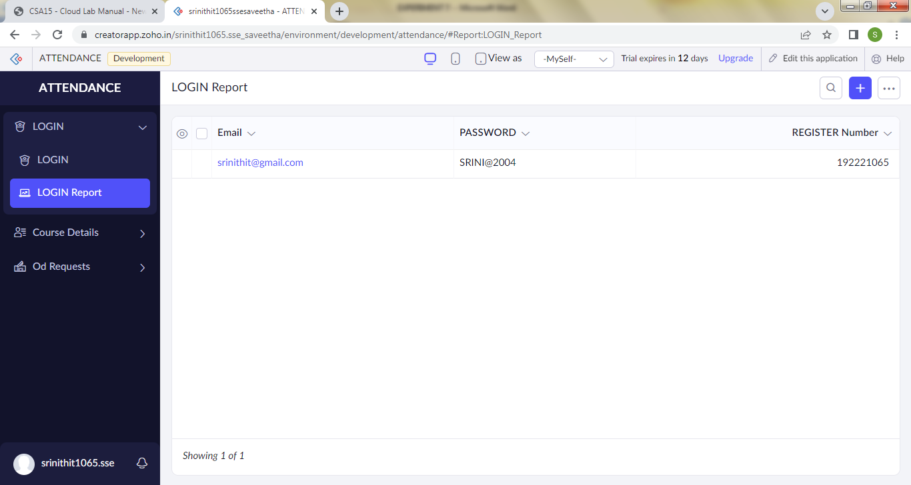

Step 10: - Click on the mobile icon to see the output in mobile format

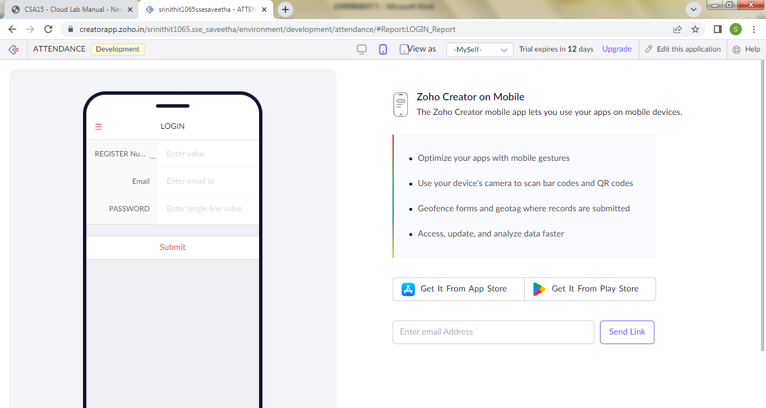

Step 11: - Click on the tablet icon to see the output in tablet format

